**BIOMEDICAL SCIENCE ACADEMY**

**Student Classroom Syllabi/Handbook**

**Principles of Biomedical Science**

**PLTW**

**2018 -2019**

**Saddleback High School**

Mr. Hernandez, Instructor

**PROGRAM**: Principles of Biomedical Science

**(Project Lead the Way)**

**COURSE ACRONYM:** PBS

**ROOM NUMBER:** 618B

**INSTRUCTOR:**  Mr. Danny Hernandez

Saddleback High School,

2802 S Flower St,

Santa Ana, CA 92707

E-mail address: [danny.hernandez@sausd.us](mailto:danny.hernandez@sausd.us)

**PREREQUISTIES:**

Length of course: 2 Semesters

Grade level: 10

Prerequisite: An interest in the biomedical field

Class size: ~30

**WELCOME** to Project Lead the Way and the Biomedical Science Academy Program. Saddleback High School is very excited to be introducing a program that prepares students for a career in biotechnology, medicine or a health related field.

Project Lead the Way is a national, not-for-profit educational program that assists high-school students in developing strong backgrounds in science and engineering. This dynamic program uses hands-on, real world curriculum to engage and challenge students to achieve their highest potential.

Teachers are required to train for the courses Project Lead the Way offers. I spent a month in San Diego training for Human Body Systems. This course is rigorous and challenging. Although intensive, it will increase student motivation, cooperative learning skills, higher-order thinking and enhance overall improvement providing optimum student achievement.

In conjunction with Project Lead the Way, Saddleback High School will provide the opportunity for students to experience the world of science and medicine by applying knowledge in real-world situations as they advance through the pathways.

The following is the link to Project Lead the Way. Please visit the website for information regarding the Biomedical Science Academy Program.

<http://www.pltw.org/Biomedical/biomedical.cfm>



*PBS SYLLABI*

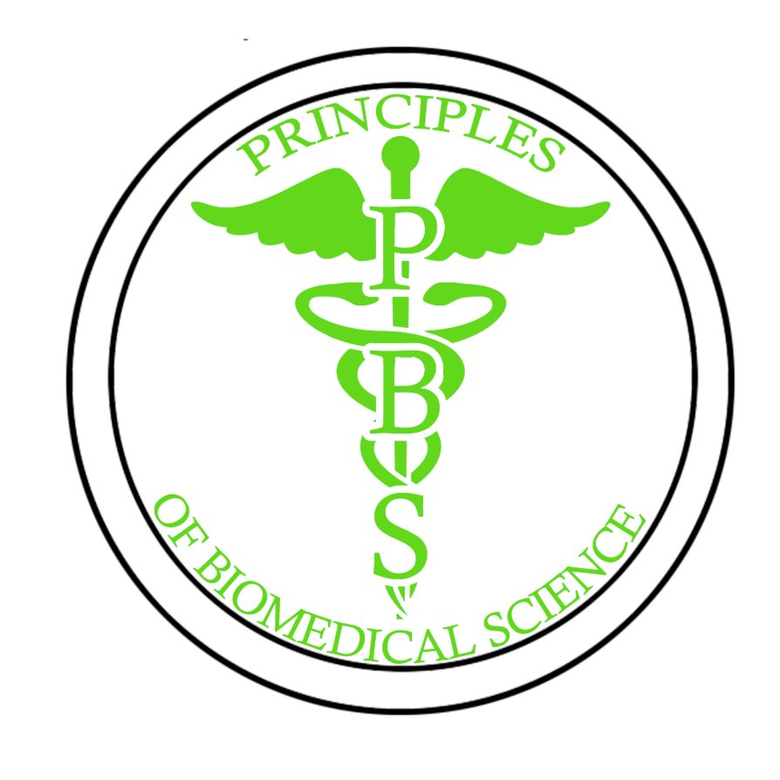

**COURSE DESCRIPTION:**

In Principles of Biomedical Science (PBS), the introductory course of the PLTW Biomedical Science program, students explore concepts of biology and medicine to determine factors that led to the death of a fictional person. While investigating the case, students examine autopsy reports, investigate medical history, and explore medical treatments that might have prolonged the person’s life. The activities and projects introduce students to human physiology, basic biology, medicine, and research processes while allowing them to design their own experiments to solve problems.

Course Content includes the following units:

**Unit One – The Mystery**

The goal of Unit 1 is to provide the foundation and develop the theme for the course. Students are engaged by reading about a woman, Anna Garcia, who is found dead in her home. Students investigate the scene, gather evidence, and then move to the lab to analyze their findings. Through their examination of key evidence, students learn notebook organization, observation and documentation skills, and the fundamentals of experimental design. Students are introduced to the structure of DNA and investigate how basic molecular biology techniques can be used to connect suspects with a crime scene. Students also discuss the bioethics of scientific research and explore the bounds of HIPAA legislation. In each unit of the course, students obtain additional medical history information for Anna as well as details from her autopsy report as they explore the various illnesses she encountered throughout her life. Students will maintain a medical file for Anna Garcia, compile their ideas and findings over the duration of the course, and ultimately determine her cause of death in the final unit.

**Unit Two – Diabetes**

The goal of Unit 2 is for students to walk through Anna Garcia’s diagnosis of diabetes by completing simulated laboratory tests. Given results of the tests, students can deduce the basic biology of both Type 1 and Type 2 diabetes. Students investigate the connection between insulin and glucose and discuss how feedback systems in the body regulate the function of key hormones. Students investigate the biochemical makeup of food and complete experiments to demonstrate the relationship between energy and food. As students explore diabetes, they are introduced to basic chemistry, the structure and function of macromolecules, and the relationship of these molecules to metabolic function. The causes, symptoms, treatments, and side effects of diabetes are studied as well as the lifestyle implications associated with this disease. Students examine complications related to diabetes and finally brainstorm and develop an innovation to help with the management or treatment of the disease.

**Unit Three – Sickle Cell Disease**

The goal of Unit 3 is for students to learn basic concepts of genetics and inheritance as they explore Anna Garcia’s struggle with sickle cell disease. Students examine sickled red blood cells under a microscope and learn what life is like with the disease by reading and writing patient diary entries. They simulate the process of protein synthesis, examine the assembly of the protein hemoglobin, and demonstrate how sickle cell disease results from a mutation that alters a protein product. Students examine the structure of chromosomes and show how traits are passed through generations on the chromosomes in our cells.

**Unit Four – Heart Disease**

The goal of Unit 4 is for students to examine the normal function of the human heart and investigate malfunctions in the cardiovascular system that can lead to heart disease. Students complete a dissection to tour heart anatomy and study heart function using probes and data acquisition software. They collect and analyze heart data, including heart rate, blood pressure, and EKG readings and analyze cardiac test results of Anna Garcia. Students explore the role cholesterol plays in the body. Students further their knowledge of molecular biology as they run gel electrophoresis and complete RFLP analysis to diagnose familial hypercholesterolemia. Students design models to simulate the function of a pump and design visuals to show interventions for blocked coronary vessels.

**Unit Five – Infectious Disease**

The goal of Unit 5 is to introduce students to microbiology and infection. Students follow the spread of a simulated epidemic in order to conduct a thorough examination of the agents of disease. Students use clues from their investigation of Anna Garcia’s medical history to deduce that she was suffering from a bacterial infection. Through a series of laboratory investigations, students learn the fundamentals of aseptic technique, complete visual identification of bacterial morphology, use the Gram stain to examine bacterial cell structure, and analyze the results of metabolic tests to pinpoint the particular bacterium at the heart of the illness. Students explain the functioning of the human immune system in a visual project and explore how this system is designed to protect against invaders.

**Unit Six – Post Mortem**

The goal of Unit 6 is for students to put together all they have learned throughout the course to determine Anna Garcia’s cause of death. Students will investigate the structure and function of key human body systems and relate the illnesses in the course to a breakdown in these systems. Students will begin to recognize the coordination and interconnections of the body systems required to maintain homeostasis, a precursor to the theme of the Human Body Systems (HBS) course.

**INSTRUCTIONAL PROCEDURES:**

Instructional materials may include but not limited to individual learning activity packets, lecture, worksheets, visual aids, outside speakers and Internet access. The student learner participation in the form of questions, reinforcement of academic skills, discussion of related experiences, and small group work will be encouraged. The student learner is encouraged to supplement these activities with other resources in the library or Internet. The student learner will perform return and complete assigned hands-on tasks.

**EVALUATION OF STUDENT ACHIEVEMENTS AND GRADING SYSTEM:**

The instructor of this course assumes responsibility to provide explicit information regarding expectations of students on required assignments and activities and dates for completion.

The major obligation of the student is to demonstrate proficiency while meeting the requirements for this course. Included in this obligation is the necessity of meeting timetables for completion of activities, assignments, and tests. Students who need additional help should notify the instructor who will provide additional assistance.

**Breakdown of 1st semester grade Grades:**

The following scale will be used to assign grades at the end of the 1st semester.

30% - Assessments A= 100% - 90%

25% - Labs/Projects B = 89% - 80%

20% - Classwork/Lab Journals C = 89% - 70%

10% - Participation D = 79% - 60%

15% - End Of Course Exam (EOC) F = 69% and Below

**ADDITIONAL BREAK DOWN OF GRADES:**

1. Homework needs to be completed on the due date for full credits. Any late homework/assignments will result in a loss of 50% points per day.
2. Quizzes are worth varied points per question.
3. Any student that turns in identical work as another or any preexisting work on the internet will be given a zero.
4. Tests may be administered in many forms, for example, multiple choices, scientific report, journal writing etc. This means that test will be graded according to the assignments and students will be informed prior to taking the test.
5. Laboratory activities are worth varied points. A student will be pulled out of laboratory activities, if any safety violations occur and they will receive a zero for that particular laboratory activity and then ½ a credit if the laboratory activity is made up later. Labs missed due to school activities can be made up and students will receive full credits. Labs that are missed due to “other” reasons will receive ½ credits unless there is legitimate conditions, such as, death in the family, doctor’s note etc.
6. Projects, concept maps, oral presentations and career journals will be graded using the PLTW rubric criteria, unless there are special circumstances that may not warren the use of rubrics.
7. The End of Course exam will be counted as a final grade.

Students are required to keep backup copies of all their assignments until the end of the semester. All written assignments should be in the form of complete sentences. Contractions and abbreviated words are not acceptable and this will result in loss of valuable points.

All submitted work must be in your own words. If you work with a partner on an assignment/project that requires individual submission, you must submit your own document with your partner’s name on it. In addition, you must use your own words and thoughts as much as possible to answer the questions or write any reports – otherwise copying from other students’ means plagiarism -a serious offence, which can result in students receiving a zero and a teacher/student conference with parent and program Director involvement.

**ALL** students need to be aware that **ALL** assignments are due at the beginning or end of class on the due date. Assignments submitted online must be submitted before midnight on the due date. Late assignments need to be completed within a set time and students will receive ½ credit.

A unit quiz and/or test will be administered after completion of each Unit in a form of multiple choices, laboratory reports, and research or by presentations. **Students need to be aware that late quizzes are worth full credit but must be taken the next day the student is in class.**

***\*\*\*\*The details of this syllabus, including topics covered, calendar, and grading rubrics are subject to change. You will be informed of any changes in class. \*\*\*\****

*Extra Credit*

*and*

*Required Materials*

**EXTRA CREDIT**

Extra credit is not available in this course. Extra credit assignments often distract students because they take time away from that which should be spent on the regular assignments. They promote increased understanding of related topics at the expense of the most important topics. The topics and assignments listed in the syllabus have been selected as the best way to meet the course objectives.

**REQUIRED TEXTS, MATERIALS, SUPPLIES:**

Required text books will be provided to all students. All text and curriculum for the PBS program is considered copyrighting by Project Lead the Way.

All required equipment, materials, supplies, computers and software will be provided by Saddleback High School for use by the students (providing all computer regulations and safety guidelines and laboratory procedures are followed as stated in the Student Safety Contract or as above).

Student supplies: Composition Notebook

Lab Journal

Chromebook

Pencils and pens

***\*\*\*The details of this syllabus, including topics covered, calendar and sequences of the course are subject to change. You will be informed in class of any changes. \*\*\****

*CLASSROOM*

*EXPECTATIONS*

*AND*

*STATEMENT OF UNDERSTANDING*

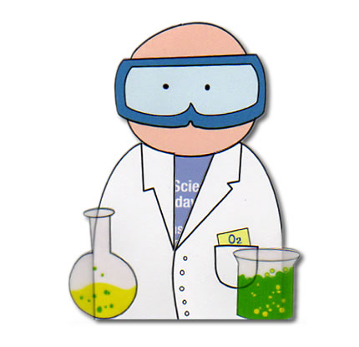

**ATTENDANCE:**

**ABSENCES:**

There will be limited time to make – up activities and/or Labs during class time due to the intensity and large material needed to be covered in the PBS program. Students are advised to be here on time.

**Make-up Work:**

It is the student’s responsibility to find out what material, work, etc. was missed on days that they were absent. Students may see me either before or after class to discuss what was missed (please do not interrupt class to find out about make-up work).

Homework is due at the beginning of class on the assigned due date. If you are absent on the day the homework is due, students are expected to hand in the work the following day.

It is up to the student to arrange times for make-ups if they are absent for tests, labs, or quizzes. Make-up sessions should be scheduled for either before or after school and should be done immediately upon the students return. Students will be given advanced notice of upcoming Tests and Quizzes; therefore, students are expected to be prepared to make-up the missed test or quiz immediately upon their return.

**A student who knows they will be absent from class on a particular date (due to sports, vacations, academic activities, etc.) is still expected to hand in any work that was assigned to be due for that day. You may hand in work the day before it is due, the morning of or on the return day, however, any work handed in later than the assigned time will be counted as late and a student will receive ½ credit for the first 9 weeks and then a zero for any missed Lab/activities after the first 9 weeks**

**TARDIES:**

Please refer to the current student handbook for policies and procedures concerning tardiness.

**EDUCTIONAL STANDARDS:**

All the Units in PBS are designed to meet the Standards for Technological Literacy, National Science Education Standards, Principles and Standards for School Mathematics, and Standards for the English Language Arts.

**CLASSROOM AND LABORATORY EXPECTED BEHAVIOR:**

**Be Prepared:**

Bring your notebook, pencils, pens, assignments, books, etc. with you to class every day. If you forget your homework in your car, locker, etc. you will not be permitted to go get it after the bell has rung.

**Be Respectful and Courteous:**

Please remember that you are not the only one in the class, and that you are to treat others in a tolerant, considerate, courteous, respectful manner at all times. This includes being on time, not sleeping in class, doing your own work, keeping your hands to yourself, speaking in a mature manner, using appropriate language, being helpful, participating in class, etc. Also, keep in mind that the students determine much of the climate of the classroom, and their actions (spoken, written, and the use of gestures), if you wish to keep the classroom environment one conducive to learning, fun, and productivity, then please use common sense when dealing with your fellow classmates, and myself. In general treat others how you wish to be treated, but please try to think a little before acting.

**Be Safe:**

It is imperative that students understand that there is to be no horse playing when doing an activity, project and/ or in the Lab. Everyone should follow the general safety precautions as listed in the Safety Lab. Student who are a danger to themselves or to others will be asked to see Mr. B and will receive a zero for any assigned work and for their daily performance grade for that day.

**Do Your Best:**

This includes every class, lab, assignment, paper, activity, etc. I expect you to try your hardest, and make you best effort. This also includes actively participating in each and every class, activity, assignment, discussion, etc. You will only get out of class as much as you put in. **ASK QUESTIONS!** If you don’t ask you’ll never know!

**ACADEMIC DISHONESTY:**

Academic honesty is expected of all Saddleback High School students. It is dishonest to misrepresent another person’s work as one’s own, to take credit for someone else’s work or ideas, to accept help on a test, to obtain advanced information on confidential test materials, or to intentionally harm another student’s chances for academic success. Please see the SBHS student handbook for further information.

**ELECTRONIC DEVICES:**

**Cell phones,** for personal use, will not be tolerated under any circumstances. They should be out of sight and out of sound unless being used for research purposes. Refer to the student handbook for cell phone policy.

**Laptops** will be assigned to each student. Students are responsible for maintaining and adhering to the correct procedure for usage of the computers. Under **no circumstances** may the computers be used for anything but Project Lead the Way unless in exceptional conditions as agreed by the instructor. If the student refuses to comply with the computer regulations, the student will lose their computer privileged and dismissed from the program.

**FOOD & DRINK:**

Food and drinks are not permitted in any of the Saddleback High School science classrooms or labs. Students who show up to class with food or drinks will be asked to leave them by the door or throw them out.

**Statement of understanding**

I have read and understand the Human Body Systems (syllabi). Procedures, and Expectations and agree to abide by them in the interest of the school, and the class in maintaining a quality education for all.

______________________________ ______________________________

Students Signature Date Parent’s Signature Date

______________________________

Parent’s Signature Date

Questions/Comments/Concerns:

***ADDITIONAL INFORMATION***



**FIELD TRIPS**

Field trips are considered a privilege. Only students who have maintained a “C” or better at SBHS are eligible for field trips. The appropriate forms need to be filled out and returned on the day specified by the instructor; otherwise the student will not be able to go.

*LABAROTARY EXPECTATIONS AND STATEMENT OF AGREEMENT*

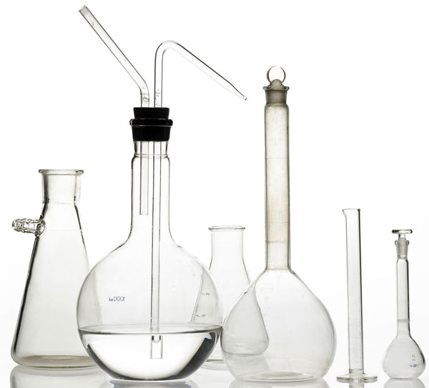

**PURPOSE:**

Science is a hands-on laboratory class. You will be doing many laboratory activities which will require the use of hazardous chemicals and material. Safety in the science classroom is the #1 priority for students, teachers and parents. To ensure a safe science classroom, a list of rules has been developed and provided to you in this Student Safety Contract. These rules must be followed at all times.

Two copies of the contract are provided. One copy must be signed by both you and a parent or guardian before you can participate in the laboratory. The second copy is to be kept in your science notebook as a constant reminder of the safety rules.

**Conduct:**

1. Do not engage in practical jokes or boisterous conduct in the laboratory.
2. Never run in the laboratory.
3. The use of personal audio or video equipment is prohibited in the laboratory – unless permission given by the instructor.
4. The performance of unauthorized experiments is strictly forbidden.
5. Do not sit on laboratory tables.

**General Work Procedure:**

1. Know emergency procedures and where the Material Safety Data System is.
2. Never work in the laboratory without the supervision of a teacher.
3. Always perform the experiments or work precisely as directed by the teacher.
4. Immediately report any spills, accidents, or injuries to a teacher.
5. Never leave experiments while in progress.
6. Never attempt to catch a falling object.
7. Be careful when handling hot glassware and apparatus in the laboratory. Hot glassware looks just like cold glassware.
8. Never point the open end of a test tube containing a substance at yourself or others.
9. Never fill a pipette using mouth suction. Always use a pipetting device.
10. Make sure no flammable solvents are in the surrounding area when lighting a flame.
11. Do not leave alcohol burners unattended.
12. Turn off all heating apparatus and water faucets when not in use.
13. Do not remove any equipment or chemicals from the laboratory.
14. Coats, bags, and other personal items must be stored in designated areas, not on the lab tables or in the aisle ways.
15. Notify the instructor of any sensitivities that you may have to particular chemicals, latex or other substances.
16. Keep the floor clear of all objects (e.g., ice, small objects, and spill liquids).

**Housekeeping:**

1. Keep work area neat and free of any unnecessary objects.
2. Thoroughly clean your laboratory work space at the end of the laboratory session.
3. Do not block the sink drains with debris.
4. Never block access to exits or emergency equipment.
5. Inspect all equipment for damage (cracks, defects, etc.) prior to use; do not use damage equipment.
6. Never pour chemical waste into the sink drains or wastebaskets without first checking with the instructor.
7. Place chemical waste in appropriately labeled waste containers.
8. Properly dispose of broken glassware and other sharp objects (e.g., syringe needles) immediately in designated containers.
9. Properly dispose of weigh boats, gloves, filter paper, and paper towels in the laboratory.

**Apparel in the Laboratory:**

1. Always wear appropriate eye protection (i.e., chemical splash goggles) in the laboratory.
2. Wear disposal gloves, as provided in the laboratory, when handling hazardous materials. Remove the gloves before exiting the laboratory.
3. Wear shoes that cover the whole foot; low-heeled shoes with non-slip soles are preferable. Do not wear sandals, open-toed shoes, open- back shoes, or high-heeled shoes in the laboratory.
4. Secure long hair and loose clothing (especially loose long sleeves, neck ties, or scarves).
5. Remove jewelry (especially dangling jewelry).
6. Synthetic finger nails are not recommended in the laboratory; they are made of extremely flammable polymers that can burn to completion and are not easily extinguished.

**Hygiene Practices:**

1. Keep your hands away from your face, eyes, mouth, and body while using chemicals.
2. Food and drink open or closed, or gum should never be brought into the laboratory or chemical storage area.
3. Never use laboratory glassware for eating or drinking purposes
4. Never use the microwave to “pop” popcorn or warm up food.
5. Do not apply cosmetics while in the laboratory or storage area.
6. Wash hands after removing gloves, and before leaving the laboratory.
7. Remove any protective equipment (i.e., gloves, lab coat or apron, chemical slash goggles) before leaving the laboratory.

**Chemical Handling:**

1. Check the label to verify it is the correct substance before using it.
2. Wear the appropriate chemical resistant gloves before handling chemicals. Gloves are not universally protective against all chemicals.
3. If you transfer chemicals from their original containers, label chemical containers as to the contents, concentration, hazard, date, and your initials.
4. Always use a spatula or scapula to remove a solid reagent from a container.
5. Do not directly touch any chemicals with your hands.
6. Never use a metal spatula when working with peroxides. Metals will decompose explosively with peroxides.
7. Hold containers away from the body when transferring a chemical or solution from one container to another.
8. Use a hot water bath to heat flammable liquids. Never heat directly with a flame.
9. Add concentration acid to water slowly. Never add water to a concentrated acid.
10. Weigh out or remove only the amount of chemical you will need. Do not return the excess to its original container, but properly dispose of it in the appropriate waste container.
11. Never touch, taste or smell any reagents.
12. Never place the container directly under your nose and inhale the vapors.
13. Never mix or use chemicals not called for in the laboratory exercise.
14. Clean up all spills properly and promptly as instructed by the teacher.
15. Dispose of chemicals as instructed by the teacher.
16. When transporting chemicals (especially 250 ml or more), place the immediate container in a secondary container or bucket (rubber, metal or plastic) designed to be carried and large enough to hold the entire contents of the chemicals.
17. Never handle bottles that wet or too heavy for you.
18. Use equipment (glassware, alcohol burner, etc,) in the correct way, as indicated by the teacher.

**Handling Glassware and Equipment:**

1. Carry glass tubing, especially long pieces, in a vertical position to minimize the likelihood of breakage and injury.
2. Never handle broken glass with your bare hands. Use a brush and dustpan to clean up broken glass. Place broken or waste glassware in the designated glass disposal container.
3. Inserting and removing glass tubing from rubber stoppers can be dangerous. Always lubricate glassware (tubing, thistle tubes, thermometers, etc.) before attempting to insert it in a stopper. Always protect your hands with towels or cotton gloves when inserting glass tubing into, or removing it from, a rubber stopper. If a piece of glassware becomes “frozen” in a stopper, take it to your instructor for removal.
4. When removing an electrical plug from its socket, gasp the plug, not the electrical cord. Hands must be completely dry before touching an electrical switch, plug, or outlet.
5. Report damage electrical equipment immediately. Look for things such as frayed cords, exposed wires, and loose connections. Do not use damage electrical equipment.
6. Examine glassware before each use. Never use chipped or cracked glassware. Never use dirty glassware.
7. If you do not understand how to use a piece of equipment, ask the instructor for help.
8. Do not immerse hot glassware in cold water; it may shatter.

**Food & Drink:**

1. No food or drinks are allowed in the labs at any point, for any reason

**Disposal of Wastes**:

1. Do not dispose of chemicals in the sink. (Rule of Thumb: If you don’t want to drink it, don’tdump it in the sink). Follow your instructor’s directions for disposal. Be sure to dispose of chemicals in the proper waste collector. Do not mix chemical waste without being instructed to do so**. Any container that is used to collect chemical waste must be properly labeled and closed at all times unless actively pouring into it.**
2. Properly dispose of animal tissue in the red or orange Biohazard bags. Never throw animal tissue in lab garbage cans. Your instructor will provide necessary detail.
3. Dispose of broken glass in the cardboard "broken glass box" in your lab. Place “Sharps” (scalpels, needles, razorblades, etc) in the sharps boxes.

Do not place general trash in the any of the specialized collection containers.

*Do not let the potential hazards listed above make you afraid to participate in the lab. If instructions are followed and care is taken, the likelihood of an accident is greatly reduced. Labs are usually the most fun part of any science course.*

**Emergency Procedure:**

1. Know the location of all the exits in the laboratory, classroom and H building.
2. Know the location of the classroom telephone.
3. Know the location of and know how to operate the following:

* Fire extinguishers
* Alarm systems with pull stations
* Fire blankets
* Eye wash
* Fire- aid kit
* Deluge safety shower

In case of an emergency or accident, each student will need to be familiar with each of the following instructor, so that extra assistance can be obtained:

* Mrs. Diaz – Room 618 a (next door to classroom)
* Ms. Morgan – Room 405 (across from the lab)

**Questions: Name: ____________________________**

1. Do you wear contact lens? Yes___ No____
2. Are you color blind? Yes____ No____
3. Do you have any allergies? Food: Yes ____ No ___

Drugs: Yes____ No ___

If so, list specific allergies: __________________________________

**Statement of Agreement On Laboratory Safety/ Expectations**

I, _____________________________ have read and agree to follow all of the above safety rules set forth in this contract. I realize that I must obey these rules to insure my own safety, and that of my fellow students and instructors. I will cooperate to the fullest extent with my instructor and fellow students to maintain a safe laboratory environment. I will also closely follow the oral and written instructions provided by the instructor. I am aware that any violations of this safety contract that result in unsafe conduct in the laboratory or misbehavior on my part, may result in being removed from the laboratory, receiving a failing grade, or dismissal from the course.

_________________________________

Student Signature

_________________________________ _________________

Student Printed Name Date

Dear Parent or Guardian,

We at Saddleback High School, feel that you should be informed regarding the school’s effect to create and maintain a safe science laboratory environment.

With the cooperation of the instructors, parents and students, a safety instruction program can eliminate, prevent, and correct possible hazards.

You should be aware of the safety instructions your son or daughter will receive before engaging in any laboratory work. Please read the list of safety rules above. No student will be permitted to perform laboratory activities unless this contract is signed by both the student and parent/guardian and is on file with the teacher.

Your signature on this contract indicates that you have:

1. Read this Student Safety Contract.
2. Are aware of the measures taken to insure the safety of your son or daughter in the science laboratory at Saddleback High School.
3. Will instruct your son or daughter to uphold his/her agreement to follow these rules and procedures in the laboratory at Saddleback High School.

_________________________________ ______________________

Parent/Guardian Signature Date